Explainable AI-Based Depression Risk Prediction Using Lifestyle and Psychological Factors

Name: - Momin Sohail Amir
Organization: - Digital Ipsum Pvt Ltd.
Project Domain: -
Data Science | Machine Learning | Explainable Artificial Intelligence (XAI)
Role: -
Data Science Intern
Project Duration : - June 2026 – August 2026
Programming Language: - Python 3.12
Frameworks: - Streamlit, FastAPI
Development Tools: - Visual Studio Code, Git, GitHub, Jupyter Notebook

Abstract
Mental health disorders, particularly depression, have become a significant public health concern due to increasing academic pressure, occupational stress, unhealthy lifestyles, and reduced social interaction. Early identification of individuals at risk of depression is essential for timely intervention and improved mental well-being. However, many traditional machine learning models function as "black boxes," providing predictions without explaining the reasoning behind them. This lack of transparency limits user trust and reduces the practical adoption of artificial intelligence in healthcare applications.
This project presents an Explainable AI-Based Depression Risk Prediction System that combines machine learning with Explainable Artificial Intelligence (XAI) techniques to provide accurate and interpretable predictions. The proposed system utilizes an XGBoost Classifier trained on a dataset containing demographic, lifestyle, work-related, psychological, and clinical history factors. A complete machine learning pipeline was developed, including data preprocessing, categorical feature encoding, model training, hyperparameter tuning, and performance evaluation to ensure robust prediction accuracy.
To enhance the transparency of the prediction process, the SHAP (SHapley Additive exPlanations) framework was integrated into the system. SHAP identifies the contribution of individual features toward each prediction, enabling users to understand the primary factors influencing their depression risk. Based on these feature contributions, the system also generates personalized recommendations to encourage healthier lifestyle choices and improve mental well-being.
Keywords : - (Explainable Artificial Intelligence (XAI), Depression Risk Prediction, Machine Learning, XGBoost SHAP (SHapley Additive exPlanations), Mental Health Assessment, FastAPI, Streamlit, Predictive Analytics, Healthcare Analytics)

CHAPTER 1
INTRODUCTION
  - Background
Depression is one of the most common mental health disorders affecting millions of people worldwide. It influences an individual's emotional well-being, cognitive abilities, social relationships, and overall quality of life. According to the World Health Organization (WHO), depression has become a significant public health concern due to its increasing prevalence across different age groups and professions. Early identification of individuals who may be at risk is essential for timely intervention and appropriate mental health support.
In recent years, Artificial Intelligence (AI) and Machine Learning (ML) have emerged as powerful technologies in the healthcare sector. These technologies enable predictive analysis by identifying hidden patterns within large datasets that may not be easily recognized through traditional methods. Machine learning models can analyze various demographic, lifestyle, psychological, and work-related factors to estimate an individual's mental health risk with high accuracy.
However, one of the major challenges associated with machine learning models is their lack of interpretability. Many high-performing algorithms, such as ensemble learning models, often function as "black-box" systems, making it difficult for users to understand how predictions are generated. This limitation reduces trust and acceptance, especially in sensitive domains such as healthcare.
To overcome this limitation, Explainable Artificial Intelligence (XAI) techniques have been introduced. XAI improves transparency by providing understandable explanations for model predictions. In this project, SHapley Additive exPlanations (SHAP) has been integrated with the machine learning model to identify the most influential factors contributing to each prediction.
The proposed system combines machine learning, explainable AI, FastAPI, and Streamlit to develop an end-to-end Depression Risk Prediction System. The application predicts the depression risk level of an individual based on lifestyle and psychological factors while also providing explanations and personalized recommendations to enhance user understanding.

  - Problem Statement
Depression is a rapidly growing mental health concern, but identifying individuals at risk at an early stage remains a challenging task. Traditional screening methods often require professional assessment and may not always be accessible, especially for individuals who hesitate to seek medical help. Although machine learning models have demonstrated high predictive performance in healthcare applications, many of these models operate as black-box systems that fail to explain the reasoning behind their predictions.
The absence of interpretability reduces user trust and limits the practical adoption of such systems in mental health assessment. Therefore, there is a need for an intelligent, transparent, and user-friendly system that not only predicts depression risk accurately but also explains the contributing factors behind each prediction.
This project addresses this challenge by developing an Explainable AI-based Depression Risk Prediction System that integrates machine learning, SHAP explainability, FastAPI, and Streamlit to provide accurate predictions along with meaningful explanations and personalized recommendations.

  - Objectives
- To develop a machine learning model for predicting depression risk using lifestyle, demographic, psychological, and work-related factors.
- To compare the performance of multiple machine learning algorithms and select the best-performing model.
- To improve prediction transparency by integrating SHAP-based Explainable AI.
- To provide users with personalized recommendations based on important contributing factors.
- To develop a user-friendly web application using Streamlit.
- To build a RESTful API using FastAPI for real-time prediction.

  - Scope of the Project
The scope of this project is limited to predicting depression risk levels based on the information provided by the user. The system classifies users into three categories: Low Risk, Moderate Risk, and High Risk. The prediction is generated using a trained XGBoost machine learning model and is supported by SHAP explainability to improve transparency.
The application is designed for educational, research, and awareness purposes. It can assist individuals in understanding potential mental health risks based on lifestyle and psychological indicators. However, the system is not intended to replace professional medical diagnosis or psychological evaluation. Future enhancements may include integration with clinical datasets, cloud deployment, authentication mechanisms, and healthcare management systems.

  - Project Contributions
- Developed an end-to-end machine learning pipeline for depression risk prediction.
- Compared multiple machine learning algorithms, including Logistic Regression, Decision Tree, Random Forest, and XGBoost.
- Selected XGBoost as the final model based on its superior predictive performance.
- Integrated SHAP (SHapley Additive Explanations) to improve model interpretability.
- Developed a REST API using FastAPI for real-time predictions.
- Designed an interactive Streamlit-based web application for user assessment.
- Implemented personalized recommendations based on the most influential contributing factors.

  - Chapter Summary
This chapter introduced the concept of depression risk prediction and emphasized the importance of Explainable Artificial Intelligence in developing transparent and reliable healthcare decision-support systems. It discussed the background of the study, identified the problem statement, and presented the objectives, scope, motivation, and significance of the proposed project.
The chapter also highlighted the need for an interpretable machine learning solution capable of accurately predicting depression risk while providing meaningful explanations for its predictions. The proposed system aims to bridge the gap between predictive performance and model transparency through the integration of Explainable AI techniques.
The next chapter presents a comprehensive review of existing literature related to depression prediction, machine learning algorithms, and Explainable Artificial Intelligence. It also identifies the research gap that motivated the development of the proposed system.

CHAPTER 2
LITERATURE SURVEY
2.1 Introduction
Mental health assessment has become an active area of research due to the increasing prevalence of depression and anxiety worldwide. Researchers have explored various machine learning and deep learning techniques to predict depression using demographic, behavioral, lifestyle, and psychological factors. Recent studies have also focused on improving the transparency of machine learning models by incorporating Explainable Artificial Intelligence (XAI) techniques. This chapter reviews several existing research works related to depression prediction, explainable AI, and web-based mental health assessment systems. The analysis of these studies provides valuable insights into existing methodologies, their strengths, and their limitations, which helped in designing the proposed system.

2.2 Literature Review
Paper 1
Title
Depression Detection Using Machine Learning Techniques
Authors
A. Sharma, R. Gupta, and P. Singh
Year
2022
Summary
This study investigates the application of various machine learning algorithms for predicting depression using demographic and psychological features. The authors evaluated Logistic Regression, Support Vector Machine, Random Forest, and Decision Tree classifiers. The study concluded that ensemble learning methods produced better predictive performance compared to traditional machine learning models. The research demonstrated that machine learning can assist healthcare professionals in identifying individuals who may be at risk of depression.

Paper 2
Title
Explainable Artificial Intelligence for Healthcare Applications
Authors
S. Lundberg and S. Lee
Year
2017
Summary
This research introduced SHAP (SHapley Additive Explanations), a unified explainability framework based on cooperative game theory. SHAP provides local explanations for individual predictions by calculating the contribution of each feature. The framework has become one of the most widely accepted methods for interpreting machine learning models, especially in healthcare applications where transparency is essential.

Paper 3
Title
Mental Health Prediction Using Ensemble Learning
Authors
M. Khan, S. Ali, and R. Ahmed
Year
2023
Summary
The authors proposed an ensemble learning approach for predicting mental health conditions using demographic and lifestyle factors. Several ensemble models were compared, including Random Forest, Gradient Boosting, and XGBoost. The results showed that XGBoost achieved the highest prediction accuracy while maintaining good generalization performance. The study highlighted the effectiveness of ensemble learning in handling structured healthcare datasets.

Paper 4
Title
Web-Based Mental Health Assessment System Using Machine Learning
Authors
L. Johnson and P. Williams
Year
2021
Summary
This paper presented a web application for assessing mental health using machine learning models. The system allowed users to complete online questionnaires and receive predictions regarding their mental health status. Although the application improved accessibility, it lacked explainability and detailed visualization of prediction results.

Paper 5
Title
Early Detection of Depression Using Explainable Machine Learning Models
Authors
Y. Chen, H. Zhang, and J. Wang
Year
2024
Summary
This research combined machine learning with explainable AI to improve the early detection of depression. The authors used SHAP values to explain feature importance for individual predictions and demonstrated that explainability increased user confidence in the prediction results. The study emphasized the importance of transparency when deploying AI systems in healthcare environments.

2.3 Comparative Analysis of Existing Work
Research Work | Machine Learning | Explainable AI | Web Application | Recommendations | Limitation
Paper 1 | Yes | No | No | No | Black-box prediction
Paper 2 | No | Yes | No | No | Explainability only
Paper 3 | Yes | No | No | No | No interpretability
Paper 4 | Yes | No | Yes | No | Limited transparency
Paper 5 | Yes | Yes | No | No | No deployment
Proposed System | Yes | Yes (SHAP) | Yes | Yes | Educational and research purpose

2.4 Research Gap
The literature survey indicates that existing research has achieved significant progress in depression prediction using machine learning algorithms. However, many studies focus primarily on improving predictive accuracy while overlooking the importance of model interpretability. Several research works lack Explainable AI techniques, making it difficult for users and healthcare professionals to understand how predictions are generated. Similarly, some studies provide explainability but do not implement a complete end-to-end application for practical use. Furthermore, most existing systems do not offer personalized recommendations based on the identified risk factors.
To address these limitations, the proposed project integrates an XGBoost-based prediction model with SHAP explainability, a FastAPI backend, and a Streamlit-based frontend. In addition to predicting depression risk, the system highlights the most influential contributing factors and provides personalized recommendations, resulting in a transparent and user-friendly end-to-end mental health assessment system.

2.5 Motivation of the Proposed Work
The increasing prevalence of depression and other mental health disorders has highlighted the need for accessible, accurate, and interpretable decision-support systems. Although several machine learning models have been proposed for depression prediction, many existing approaches primarily focus on achieving high prediction accuracy while offering limited insight into the reasoning behind their predictions. This lack of transparency reduces user confidence and limits the practical adoption of such systems, particularly in healthcare-related applications.
Another significant limitation observed in previous studies is the absence of user-friendly deployment platforms. Many research works remain confined to experimental environments and are not implemented as interactive applications that can be easily accessed by end users. Furthermore, most existing systems provide only prediction results without offering personalized recommendations that could help users understand and improve their mental well-being.
These limitations motivated the development of the proposed Explainable AI-Based Depression Risk Prediction System. The proposed work combines the high predictive capability of the XGBoost algorithm with the interpretability of SHAP (SHapley Additive exPlanations) to provide transparent and reliable predictions. Additionally, the integration of FastAPI and Streamlit enables real-time prediction through an interactive web application, while the recommendation module converts prediction explanations into practical guidance for users.
The motivation behind this project is not only to build an accurate depression risk prediction model but also to develop a system that is transparent, explainable, user-friendly, and practically deployable, thereby bridging the gap between machine learning research and real-world healthcare applications.

2.6 Chapter Summary
This chapter presented a comprehensive review of existing research related to depression risk prediction, machine learning techniques, and Explainable Artificial Intelligence (XAI). Various studies were analyzed to understand the methodologies, algorithms, datasets, and evaluation techniques adopted by previous researchers. The review highlighted both the strengths and limitations of existing approaches, particularly in terms of model interpretability, deployment, and user accessibility.
Based on the literature survey, a research gap was identified, emphasizing the need for a depression prediction system that combines high predictive accuracy with transparent decision-making and practical usability. The motivation behind the proposed work was subsequently discussed, outlining the importance of integrating Explainable AI with a real-time web-based application to improve user trust and system accessibility.
The insights gained from the literature review and research gap analysis provide a strong foundation for the proposed system. The next chapter describes the research methodology adopted for the development of the Explainable AI-Based Depression Risk Prediction System, including dataset preparation, data preprocessing, feature engineering, model development, hyperparameter tuning, and the integration of SHAP for prediction explainability.

CHAPTER 3
PROPOSED METHODOLOGY
3.1 Introduction
The proposed methodology describes the systematic approach adopted for designing and developing the Explainable AI-based Depression Risk Prediction System. The methodology covers every stage of the project, beginning with dataset collection and ending with the deployment of a complete web-based application. The primary objective was to develop an accurate, interpretable, and user-friendly system capable of predicting an individual's depression risk using demographic, lifestyle, work-related, and psychological attributes.
The development process followed a structured machine learning pipeline to ensure consistency, reproducibility, and scalability. Initially, a suitable dataset was collected and analyzed to understand its characteristics. Data preprocessing techniques were then applied to improve data quality by handling categorical variables and preparing the dataset for model training. Several machine learning algorithms were trained and evaluated, after which XGBoost was selected as the final prediction model due to its superior performance.
To enhance model transparency, SHapley Additive exPlanations (SHAP) were incorporated to identify the most influential features contributing to each prediction. A FastAPI backend was developed to serve the trained model as a RESTful API, while a Streamlit frontend was implemented to provide an interactive interface for user assessment and result visualization. The integration of these technologies resulted in a complete end-to-end machine learning system capable of delivering real-time predictions along with meaningful explanations and personalized recommendations.

3.2 System Architecture
The proposed system follows a modular architecture consisting of multiple interconnected components. Each component performs a specific task in the prediction pipeline, ensuring efficient data processing and accurate depression risk assessment. The architecture begins with user interaction through the Streamlit interface, where users provide demographic, lifestyle, work-related, and psychological information by answering a structured questionnaire.
The collected information is transmitted to the FastAPI backend through an HTTP POST request. The backend validates the received data using Pydantic schemas before forwarding it to the trained machine learning pipeline. The preprocessing module transforms the input features using the same transformations applied during model training, ensuring consistency between training and inference.
The processed data is then passed to the XGBoost classifier, which predicts the user's depression risk category. Following prediction, SHAP is used to calculate feature contributions, allowing the system to explain the reasoning behind the prediction. Based on these influential features, a recommendation engine generates personalized suggestions aimed at promoting mental well-being. Finally, the prediction result, confidence score, feature explanations, and recommendations are returned to the Streamlit application for visualization.
The modular design improves maintainability, scalability, and deployment flexibility by separating user interaction, backend processing, machine learning inference, and explainability into independent components.

Fig 3.1 System Architecture
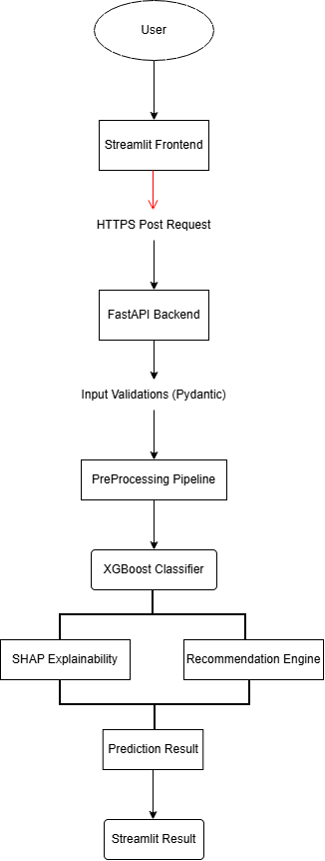
3.3 Workflow of the System Architecture
The overall workflow of the proposed system consists of several sequential stages that transform raw user information into an explainable depression risk prediction. Each stage contributes to improving the reliability, interpretability, and usability of the final system.
The workflow begins with collecting relevant information from the user through a structured questionnaire. The questionnaire captures demographic details, lifestyle habits, work-related information, psychological indicators, and clinical history. Once the user submits the assessment, the data is transmitted to the FastAPI backend.
The backend validates the received data before passing it through the preprocessing pipeline. The preprocessing stage performs feature transformations identical to those used during model training, ensuring consistency between the training and deployment environments. The transformed data is then supplied to the trained XGBoost model, which predicts one of the three depression risk categories: Low Risk, Moderate Risk, or High Risk.
Following prediction, SHAP is used to determine the contribution of individual features toward the predicted outcome. These explanations increase transparency by helping users understand why the model generated a particular prediction. Based on the most influential features, personalized recommendations are generated to encourage healthier lifestyle choices and improve mental well-being.
Finally, the complete prediction report, including the predicted risk level, confidence score, feature contributions, and recommendations, is returned to the Streamlit application and presented to the user through an intuitive graphical interface.

3.4 Dataset Description
The quality and relevance of the dataset play a significant role in determining the performance of any machine learning model. For this project, a structured dataset containing demographic, lifestyle, occupational, psychological, and medical history attributes was utilized to predict an individual's depression risk level. The dataset was selected because it contains multiple factors that are commonly associated with mental health conditions and provides sufficient information for building a robust classification model.
The dataset consists of 25,000 records, with each record representing an individual and their associated characteristics. Every observation includes several independent variables describing the individual's lifestyle, work environment, mental health indicators, and family medical history. The target variable categorizes the individual into one of three depression risk levels: Low Risk, Moderate Risk, and High Risk.
The dataset is balanced enough to train machine learning models effectively while maintaining realistic variations among different classes. The availability of numerical, categorical, and binary features makes it suitable for demonstrating preprocessing techniques such as encoding, scaling, and feature engineering.
The dataset serves as the primary source for training, validating, and testing the machine learning models developed in this project.
3.4.1 Dataset Source
The dataset used in this project was obtained from Kaggle, an online platform that provides publicly accessible datasets for machine learning and data science research. The selected dataset focuses on mental health assessment using demographic, lifestyle, occupational, and psychological indicators.
The dataset was selected because it contains multiple attributes associated with depression risk and is appropriate for supervised machine learning classification tasks.

3.4.2 Dataset Characteristics
Attribute | Description
Dataset Type | Structured Tabular Dataset
Total Records | 25,000
Total Features | 24 Input Features
Target Classes | 3
Prediction Type | Multi-Class Classification
Missing Values | None
Numerical Features | Yes
Categorical Features | Yes
Binary Features | Yes

3.4.3 Feature Description
The dataset contains twenty-four independent variables representing different aspects of an individual's life. These variables are grouped into logical categories for better understanding.
Feature | Description
Age | Age of the individual
Gender | Gender of the individual
Marital Status | Current marital status
Education Level | Highest educational qualification
Employment Status | Current employment status
Lifestyle Features : -
Feature | Description
Sleep Hours | Average sleeping hours per day
Physical Activity Hours per Week | Weekly exercise duration
Screen Time Hours per Day | Daily recreational screen time
Social Support Score | Perceived family and social support

Work and Academic Features
Feature | Description
Working Hours per Week | Weekly working hours
Work Stress Level | Stress experienced at work
Academic Pressure Level | Academic workload and pressure
Job Satisfaction Score | Satisfaction with current work

Psychological Features
Feature | Description
Anxiety Score | Anxiety level reported by the individual
Depression Score | Depression severity indicator
Stress Level | Overall stress experienced
Mood Swings Frequency | Frequency of emotional fluctuations
Concentration Difficulty Level | Difficulty maintaining concentration

Clinical History Features
Feature | Description
Panic Attack History | Previous panic attack occurrence
Family History of Mental Illness | Family history of mental disorders
Previous Mental Health Diagnosis | Previous clinical diagnosis
Therapy History | Previous counselling or therapy
Substance Use | Substance consumption history
3.4.4 Target Variable
The dependent variable of the dataset is Depression Risk, which represents the depression risk level predicted by the machine learning model.
The target variable consists of three classes.
Label | Risk Level
0 | Low Risk
1 | Moderate Risk
2 | High Risk

3.5 Data Collection
Data collection is one of the most important stages in any machine learning project because the quality of the collected data directly influences model performance. The dataset used in this project was obtained from a publicly available repository and carefully examined before model development.
After downloading the dataset, an initial inspection was performed to understand its structure, number of observations, feature types, and target variable distribution. Various exploratory operations such as checking dataset dimensions, identifying feature categories, inspecting summary statistics, and verifying data quality were carried out before preprocessing.
Since the dataset did not contain missing values or duplicate records, no extensive data cleaning was required. However, categorical variables were prepared for encoding, and numerical variables were identified for feature scaling during the preprocessing stage. This ensured that the dataset was suitable for training multiple machine learning algorithms without introducing inconsistencies.
The collected dataset provided sufficient diversity across demographic, lifestyle, psychological, and occupational factors, making it appropriate for developing a generalized depression risk prediction model.

3.5.1 Data Collection Process
The following steps were followed during the data collection phase:
- Identification of a suitable mental health dataset.
- Downloading the dataset from a trusted public repository.
- Importing the dataset into the Python environment using Pandas.
- Inspecting dataset dimensions and feature information.
- Verifying data quality by checking for missing values and duplicate records.
- Identifying categorical, numerical, and binary features.
- Preparing the dataset for exploratory data analysis and preprocessing.

3.6 Exploratory Data Analysis (EDA)
Exploratory Data Analysis (EDA) was performed to gain a better understanding of the dataset before model training. EDA helps identify hidden patterns, detect anomalies, understand feature distributions, and examine relationships among variables. A thorough exploratory analysis also assists in selecting appropriate preprocessing techniques and machine learning algorithms.
Several visualization and statistical techniques were used during this phase to examine the characteristics of the dataset.
The following analyses were performed:
- Dataset shape and dimensions.
- Data type inspection.
- Summary statistics of numerical variables.
- Distribution of categorical variables.
- Target class distribution.
- Correlation analysis.
- Outlier detection.
- Feature importance exploration.

3.6.1 Dataset Inspection
The initial inspection revealed that the dataset contained 25,000 observations with 24 independent features and one target variable. Both numerical and categorical features were present, requiring different preprocessing strategies before model training.
3.6.2 Missing Value Analysis
The dataset was examined for missing values using Pandas functions. The analysis confirmed that no missing values were present in any feature, allowing the preprocessing stage to proceed without applying imputation techniques.
3.6.3 Duplicate Record Analysis
Duplicate observations were checked to ensure that repeated records would not bias the machine learning model. No duplicate entries were identified in the dataset.
3.6.4 Target Variable Distribution
The distribution of depression risk categories was analyzed to determine whether the dataset suffered from severe class imbalance. Although the three classes were not perfectly balanced, each class contained a sufficient number of observations to train robust machine learning models.
3.6.5 Correlation Analysis
Correlation analysis was performed to examine linear relationships among numerical variables. The correlation matrix indicated that most features exhibited weak pairwise correlations, suggesting that depression risk is influenced by the combined effect of multiple independent factors rather than any single variable.
This observation justified the use of ensemble learning methods such as XGBoost, which can effectively capture complex non-linear relationships between features

3.6.6 Exploratory Analysis Summary
The exploratory data analysis confirmed that the dataset was clean, well-structured, and suitable for machine learning. No missing values or duplicate records were detected, and the target variable exhibited a reasonable class distribution. The insights obtained during this phase guided the preprocessing and feature engineering steps described in the subsequent sections.

3.7 Data Preprocessing
Data preprocessing is one of the most critical stages in the machine learning pipeline because the quality of the input data directly influences model performance. Raw datasets often contain categorical variables, numerical variables with different scales, redundant information, and inconsistencies that must be addressed before model training. Proper preprocessing ensures that the learning algorithm receives standardized and meaningful input while reducing the possibility of biased predictions.
In this project, preprocessing was carefully designed to maintain consistency between the training and deployment environments. The same preprocessing operations applied during model training were also incorporated into the prediction pipeline used by the FastAPI backend. This approach prevents discrepancies between training data and real-time user input, thereby improving model reliability.
The preprocessing workflow included identifying feature types, encoding categorical variables, scaling numerical features, constructing a preprocessing pipeline, and integrating the preprocessing stage with the machine learning model.
3.7.1 Feature Categorization
The dataset contains three different categories of input variables:
- Numerical Features
- Categorical Features
- Binary Features
Each category requires a different preprocessing strategy.
Numerical variables represent measurable quantities such as age, sleep duration, stress scores, and working hours. Since these variables exist on different numerical scales, feature scaling was applied before model training.
Categorical variables such as gender, marital status, education level, and employment status were transformed into numerical representations using one-hot encoding.
Binary variables representing Yes/No responses were already converted into numerical values (0 and 1) and therefore required no additional preprocessing.
3.7.2 Encoding of Categorical Variables
Machine learning algorithms cannot directly process textual values such as "Male", "Female", "Single", or "Married". Therefore, categorical variables were converted into numerical representations using One-Hot Encoding.
One-Hot Encoding creates a separate binary column for each category while preserving all available information without introducing ordinal relationships among categories.
Gender_Male | Gender_Female | Gender_Other
1 | 0 | 0
0 | 1 | 0
0 | 0 | 1

3.7.3 Feature Scaling
Numerical variables in the dataset have different ranges. For example,
- Age ranges from approximately 15 to 80.
- Sleep Hours ranges between 0 and 12.
- Stress Score ranges from 0 to 10.
- Working Hours ranges up to 80.
If features with larger values dominate the learning process, the model may become biased toward those variables. To avoid this issue, numerical features were standardized using StandardScaler.
Standardization transforms every numerical feature so that it has
- Mean = 0
- Standard Deviation = 1
This improves learning stability and ensures that all numerical variables contribute proportionately during model training
3.7.4 Column Transformer
Since different preprocessing techniques were required for different feature types, a ColumnTransformer was used.
The ColumnTransformer enables separate preprocessing pipelines for different groups of variables while combining them into a single transformed dataset.
The preprocessing strategy implemented in this project is summarized below.
Feature Type | Preprocessing Technique
Numerical Features | StandardScaler
Categorical Features | OneHotEncoder
Binary Features | Passed Without Modification
3.7.5 Machine Learning Pipeline
Instead of manually preprocessing the dataset before every prediction, the preprocessing stage was integrated with the machine learning model using Scikit-learn's Pipeline.
The pipeline ensures that every input passes through the exact same preprocessing operations during both training and prediction.
The pipeline consists of three sequential stages:
- Data Preprocessing
- Feature Transformation
- Machine Learning Model
Integrating preprocessing with model training reduces implementation complexity and eliminates inconsistencies between training and inference environments.
3.7.6 Advantages of the Pipeline Approach
- Prevents inconsistent preprocessing.
- Reduces manual coding.
- Improves code maintainability.
- Simplifies deployment.
- Eliminates preprocessing errors during prediction.
- Ensures identical transformations during training and inference.

3.8 Feature Selection
Feature selection is the process of identifying the most relevant input variables that contribute to the prediction task. Selecting appropriate features improves model performance, reduces computational complexity, and enhances interpretability.
Initially, all available features were considered during exploratory analysis. Correlation analysis indicated that no single feature exhibited an extremely strong linear relationship with the target variable. This suggested that depression risk depends on the combined influence of multiple demographic, lifestyle, occupational, and psychological factors rather than any individual attribute.
Therefore, instead of eliminating variables solely based on correlation values, domain knowledge and feature relevance were considered during model development. Variables representing sleep patterns, anxiety, depression scores, stress levels, social support, work stress, family history, therapy history, and substance use were retained because previous research indicates that these factors significantly influence mental health outcomes.
The final feature set consisted of twenty-four independent variables that collectively describe an individual's mental health condition
3.8.1 Importance of Feature Selection
Feature selection offers several benefits.
- Reduces unnecessary complexity.
- Improves computational efficiency.
- Prevents redundant information.
- Enhances model interpretability.
- Supports Explainable AI analysis.
Although all selected variables were retained in the final model, SHAP was later used to determine the relative contribution of each feature toward individual predictions.

3.9 Train-Test Split
After preprocessing and feature preparation, the dataset was divided into training and testing subsets.
The purpose of separating training and testing data is to evaluate model performance on previously unseen observations. Training and evaluating a model on the same dataset may lead to overly optimistic results and poor generalization.
In this project, the dataset was divided using the 80:20 ratio.
- Training Set : 80%
- Testing Set : 20%
The training dataset was used for learning patterns from historical observations, while the testing dataset was reserved exclusively for evaluating model performance.
The split was performed before model evaluation to ensure an unbiased estimate of predictive accuracy.
3.9.1 Prevention of Data Leakage
One of the most important considerations during machine learning development is preventing data leakage.
Data leakage occurs when information from the testing dataset unintentionally influences model training. This leads to unrealistically high performance that cannot be reproduced in real-world scenarios.
To avoid data leakage, the following strategy was adopted.
- The dataset was first divided into training and testing subsets.
- Preprocessing operations were fitted only on the training data.
- The fitted preprocessing transformations were applied to the testing data without recalculating parameters.
- The same preprocessing pipeline was reused during deployment through FastAPI.
This methodology ensures that the model is evaluated fairly and remains capable of generalizing to new users.
3.9.2 Cross Validation
To obtain a more reliable estimate of model performance, 5-Fold Cross Validation was performed during model evaluation.
In five-fold cross validation, the training dataset is divided into five equal subsets. During each iteration, four subsets are used for training while the remaining subset is used for validation. This process is repeated five times so that every subset serves as the validation set exactly once.
The average validation accuracy obtained across all folds provides a more robust estimate of model performance compared to a single train-test split.
Cross validation also helps identify whether the model suffers from overfitting or underfitting.

3.10 Model Development
Model development is the process of training machine learning algorithms to learn patterns from historical data and generate predictions for unseen observations. The objective of this project was to develop a robust classification model capable of accurately predicting an individual's depression risk level using demographic, lifestyle, occupational, psychological, and clinical attributes.
Since the problem involves predicting one of three possible risk categories, it was formulated as a multi-class classification problem. Multiple supervised machine learning algorithms were trained and evaluated to identify the model that offered the best balance between predictive accuracy, generalization capability, and computational efficiency.
Each algorithm was trained using identical preprocessing techniques and evaluated using the same training and testing datasets to ensure a fair comparison.
3.10.1 Machine Learning Algorithms Evaluated
Several supervised learning algorithms were considered during model development. Each algorithm has different strengths and limitations, making comparative evaluation essential before selecting the final model.
The following algorithms were evaluated:
- Logistic Regression
- Decision Tree
- Random Forest
- XGBoost Classifier
The performance of each model was compared using standard evaluation metrics, and the best-performing model was selected for deployment.
3.10.2 Logistic Regression
Logistic Regression is a statistical classification algorithm commonly used for binary and multiclass classification problems. It estimates the probability of class membership using a logistic function.
Although Logistic Regression is computationally efficient and easy to interpret, it assumes a relatively simple relationship between input features and the target variable. Since depression prediction involves complex interactions among multiple psychological and lifestyle factors, Logistic Regression demonstrated comparatively lower predictive performance.
Advantages
- Simple implementation.
- Fast training.
- Easy interpretation.
Limitations
- Limited ability to capture complex non-linear relationships.
- Lower predictive accuracy compared to ensemble methods.
3.10.3 Decision Tree
Decision Tree is a rule-based supervised learning algorithm that recursively partitions the dataset into smaller subsets based on feature values. Each internal node represents a decision, while each leaf node corresponds to a prediction.
Decision Trees are highly interpretable because the prediction path can be easily visualized. However, individual trees often suffer from overfitting, especially when trained on complex datasets.
Advantages
- Easy to visualize.
- Simple interpretation.
- Handles mixed data types.
Limitations
- Prone to overfitting.
- High variance.
- Sensitive to small data variations.
3.10.4 Random Forest
Random Forest is an ensemble learning algorithm that combines multiple Decision Trees to improve predictive performance. Each tree is trained using a random subset of observations and features, and the final prediction is obtained through majority voting.
Compared to a single Decision Tree, Random Forest provides better generalization and reduces overfitting. It also performs well on datasets containing numerous input variables.
Advantages
- High predictive accuracy.
- Reduces overfitting.
- Handles complex feature interactions.
- Robust against noisy data.
Limitations
- Less interpretable than a single Decision Tree.
- Larger computational requirements.
3.10.5 XGBoost Classifier
Extreme Gradient Boosting (XGBoost) is an advanced ensemble learning algorithm based on gradient boosting principles. Unlike Random Forest, which builds trees independently, XGBoost constructs trees sequentially, with each new tree correcting the errors made by previous trees.
XGBoost incorporates several optimization techniques, including regularization, parallel processing, and efficient handling of missing values, making it one of the highest-performing algorithms for structured datasets.
During experimentation, XGBoost consistently outperformed all other evaluated algorithms across multiple performance metrics.
Advantages
- Very high prediction accuracy.
- Excellent generalization.
- Handles non-linear relationships effectively.
- Efficient computation.
- Built-in regularization.
Limitations
- Less interpretable without Explainable AI.
- Hyperparameter tuning required for optimal performance.

3.11 Hyperparameter Tuning
Although XGBoost provides excellent default performance, its predictive capability can be further improved by selecting appropriate hyperparameter values.
Hyperparameter tuning is the process of searching for the optimal configuration of model parameters before training. Appropriate parameter selection reduces overfitting while improving prediction accuracy.
In this project, RandomizedSearchCV was used to identify the best hyperparameter combination.
Randomized Search evaluates randomly selected parameter combinations instead of testing every possible combination, making it computationally efficient while still producing highly optimized models.
3.11.1 Cross Validation Performance
Five-Fold Cross Validation was performed to evaluate the robustness of the optimized model.
The average cross-validation accuracy exceeded 99%, while the standard deviation remained extremely small, indicating that the model generalized consistently across different subsets of the dataset.
This confirms that the selected model is neither overfitted nor underfitted and is capable of maintaining stable performance on unseen data.

3.12 Model Evaluation
Model evaluation measures how effectively the trained classifier predicts depression risk for previously unseen observations.
Several evaluation metrics were considered to obtain a comprehensive understanding of model performance.
The following metrics were used:
- Accuracy
- Precision
- Recall
- F1-Score
- Confusion Matrix
- Cross Validation Accuracy

3.12.1 Accuracy
Accuracy represents the proportion of correctly classified observations among all predictions.
The optimized XGBoost model achieved an overall testing accuracy of approximately 99.88%, demonstrating excellent predictive capability.

3.12.2 Precision
Precision measures the proportion of correctly predicted observations among all observations predicted as belonging to a particular class.
High precision indicates that the model generates very few false positive predictions.

3.12.3 Recall
Recall measures the proportion of actual observations correctly identified by the classifier.
High recall is particularly important in healthcare applications because failing to identify individuals at high risk could have significant consequences.

3.12.4 F1-Score
The F1-Score combines precision and recall into a single metric by calculating their harmonic mean.
Since the proposed model achieved high precision and recall across all three classes, the corresponding F1-Scores were also very high.

3.12.5 Confusion Matrix
The confusion matrix provides a detailed summary of correct and incorrect predictions for each class.
The optimized XGBoost classifier produced very few misclassifications, demonstrating its ability to distinguish effectively between Low Risk, Moderate Risk, and High Risk individuals.
The confusion matrix also confirmed balanced prediction performance across all three depression risk categories.

3.12.6 Evaluation Summary
The experimental evaluation demonstrates that XGBoost significantly outperformed the other evaluated algorithms. The optimized model achieved high accuracy, precision, recall, and F1-Score while maintaining excellent generalization through five-fold cross validation.
These results justify selecting XGBoost as the final prediction model for deployment within the Explainable AI-based Depression Risk Prediction System.

3.13 Explainable Artificial Intelligence (XAI) using SHAP
Artificial Intelligence models such as XGBoost often achieve high predictive accuracy but provide limited insight into how predictions are generated. These models are commonly referred to as black-box models because their internal decision-making process is difficult for users to understand. In healthcare applications, interpretability is as important as predictive accuracy because clinicians and users need to understand the reasoning behind every prediction.
To improve transparency, this project incorporates Explainable Artificial Intelligence (XAI) using SHapley Additive exPlanations (SHAP). SHAP is a model-agnostic explainability technique based on cooperative game theory that quantifies the contribution of each feature towards the model's prediction.
For every assessment submitted by the user, SHAP calculates the importance of individual features such as sleep duration, work stress, anxiety score, depression score, and social support. The contribution of each feature is represented by an impact score, allowing users to understand which factors influenced their predicted depression risk.
Unlike traditional feature importance methods that explain the model globally, SHAP provides local explanations for every individual prediction. This means two different users with different lifestyles may receive different explanations even if they belong to the same risk category.
The integration of SHAP significantly improves model transparency, increases user trust, and supports informed decision-making by presenting meaningful explanations alongside prediction results.

3.14 Recommendation Generation
Prediction alone is often insufficient in healthcare applications. Users also require guidance regarding the factors contributing to their mental health risk. Therefore, a personalized recommendation module was developed to accompany every prediction.
The recommendation system uses the top contributing features identified by SHAP to generate practical suggestions. A predefined recommendation mapping associates each important feature with suitable mental health advice.
For example:
- If Sleep Duration is identified as a major contributing factor, the system recommends maintaining a regular sleep schedule.
- If Work Stress contributes significantly, the system advises adopting stress management techniques and maintaining a healthy work-life balance.
- If Social Support has a high impact, the user is encouraged to strengthen relationships with family and friends.
The recommendations are generated dynamically according to the individual's assessment rather than displaying the same advice to every user. This personalized approach improves the usefulness of the application and encourages users to adopt healthier lifestyle habits.
It is important to note that these recommendations are intended for awareness and educational purposes only and should not be considered a substitute for professional medical consultation.

3.15 FastAPI Backend
FastAPI was selected as the backend framework because of its high performance, automatic API documentation, and seamless integration with machine learning models. The backend acts as the communication bridge between the Streamlit frontend and the trained prediction model.
The trained preprocessing pipeline, XGBoost classifier, and SHAP explainer are loaded during application startup. Whenever a user submits the assessment, the backend validates the received information using Pydantic models before passing it through the prediction pipeline.
After prediction, the backend generates the following outputs:
- Predicted depression risk level.
- Prediction confidence score.
- Top contributing features obtained using SHAP.
- Personalized recommendations.
These outputs are returned as a JSON response to the frontend application.
3.16 Streamlit Frontend
A user-friendly web interface was developed using Streamlit to provide an intuitive experience for individuals completing the depression assessment.
The application consists of three major pages:
Landing Page
The landing page introduces the project, explains its objectives, presents important disclaimers, and allows users to begin the assessment.

3.17 End-to-End Prediction Workflow
The complete workflow of the proposed system is illustrated below.
- User accesses the Streamlit web application.
- The user completes the structured assessment questionnaire.
- Streamlit stores the responses in the current session.
- The responses are transmitted to the FastAPI backend through an HTTP POST request.
- FastAPI validates the incoming data using Pydantic.
- The preprocessing pipeline transforms the input features.
- The XGBoost classifier predicts the depression risk level.
- SHAP computes feature contributions for the prediction.
- Personalized recommendations are generated based on influential factors.
- The backend returns the prediction response to Streamlit.
- Streamlit displays the final prediction, confidence score, explanations, and recommendations to the user.
This workflow integrates data collection, machine learning inference, explainable AI, and web deployment into a unified end-to-end application.

3.18 Summary
This chapter presented the complete methodology adopted for developing the Explainable AI-Based Depression Risk Prediction System. The process began with dataset acquisition and exploratory data analysis, followed by preprocessing, feature selection, train-test splitting, and machine learning model development. Multiple classification algorithms were evaluated, with XGBoost selected as the final model due to its superior predictive performance.
To improve interpretability, SHAP was integrated into the prediction pipeline to explain individual predictions by identifying the most influential features. A recommendation module was developed to provide personalized suggestions based on these explanations. Finally, the trained model was deployed using a FastAPI backend and integrated with a Streamlit frontend to create a complete end-to-end web application capable of performing real-time depression risk assessment.

CHAPTER 4
SYSTEM DESIGN AND IMPLEMENTATION
4.1 Introduction
This chapter presents the overall design and implementation of the proposed Explainable AI-Based Depression Risk Prediction System. It describes the architecture of the application, the interaction between different software components, the implementation of the backend and frontend modules, and the deployment of the trained machine learning model.
The proposed system follows a modular architecture consisting of a user-friendly Streamlit frontend, a FastAPI backend for prediction services, a trained XGBoost classification model, and a SHAP-based Explainable Artificial Intelligence module. Each component has a specific responsibility, allowing the application to remain scalable, maintainable, and easy to understand.
The implementation was carried out using Python and several open-source libraries, ensuring compatibility, flexibility, and efficient execution throughout the development process.
4.2 System Architecture
The proposed depression prediction system follows a three-layer architecture consisting of the Presentation Layer, Application Layer, and Machine Learning Layer.
The Presentation Layer is responsible for collecting user responses through the Streamlit web application. The interface provides an organized questionnaire divided into multiple sections to simplify the assessment process.
The Application Layer consists of the FastAPI backend, which receives user responses, validates the data using Pydantic models, performs preprocessing, invokes the trained machine learning model, generates SHAP explanations, and prepares personalized recommendations.
The Machine Learning Layer contains the trained preprocessing pipeline, the optimized XGBoost classifier, and the SHAP explainer. These components work together to produce accurate predictions along with interpretable explanations.
The interaction among these layers ensures a seamless end-to-end prediction workflow while maintaining modularity and scalability.
Figure 4.1 illustrates the overall architecture of the proposed system.


4.1 System Architecture
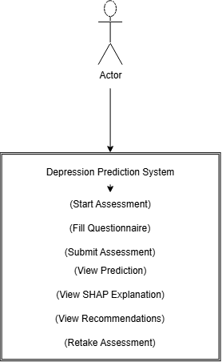
4.2 Use Case Diagram
4.3 Software Requirements
The development of the proposed system required several software tools and libraries for machine learning, web application development, API implementation, visualization, and explainability.
Table 4.1 Software Requirements
Software | Purpose
Python 3.12 | Programming Language
Visual Studio Code | Development Environment
Jupyter Notebook | Model Development
Streamlit | Frontend Web Application
FastAPI | Backend REST API
Git & GitHub | Version Control
Google Chrome | Application Testing

4.4 Python Libraries Used
Several Python libraries were utilized during different stages of development.
Table 4.2 Python Libraries
Library | Purpose
Pandas | Data Manipulation
NumPy | Numerical Computing
Matplotlib | Data Visualization
Seaborn | Statistical Visualization
Scikit-learn | Machine Learning Utilities
XGBoost | Classification Model
SHAP | Explainable AI
Streamlit | User Interface
FastAPI | Backend API
Requests | API Communication
Joblib | Model Serialization
Pydantic | Data Validation

4.5 Project Structure
To improve maintainability, the project was organized into multiple directories based on functionality.
The project contains separate modules for model development, backend implementation, frontend interface, trained model storage, and documentation.
A modular folder structure improves readability, simplifies debugging, and supports future enhancements.
Figure 4.2 presents the project directory structure.
Depression_ML
│
├── api
│ ├── main.py
│ ├── schemas.py
│ ├── predictor.py
│
├── artifacts
│ ├── model.pkl
│ ├── preprocessor.pkl
│
├── streamlit
│ ├── app.py
│ ├── api_client.py
│ ├── pages
│ │ ├── assessments.py
│ │ ├── results.py
│
├── notebook
│
├── requirements.txt
│
├── README.md
│
└── .gitignore
4.3 Folder Structure Diagram
4.6 Backend Implementation
The backend of the proposed system was implemented using FastAPI. The backend acts as an intermediary between the user interface and the machine learning model.
Its primary responsibilities include:
- Receiving user responses.
- Validating input data.
- Performing preprocessing.
- Executing prediction.
- Generating SHAP explanations.
- Producing personalized recommendations.
- Returning prediction results to the frontend.
The backend exposes a REST API endpoint that accepts HTTP POST requests containing assessment responses in JSON format.
Upon receiving the request, the preprocessing pipeline transforms the input data into a format compatible with the trained XGBoost model. The model predicts the depression risk category, after which SHAP computes feature contributions. Finally, recommendation logic generates personalized suggestions before returning the complete response to the Streamlit application.
4.6.1 API Endpoint
The backend currently exposes one prediction endpoint.
Endpoint | Method | Description
/predict | POST | Generates depression risk prediction

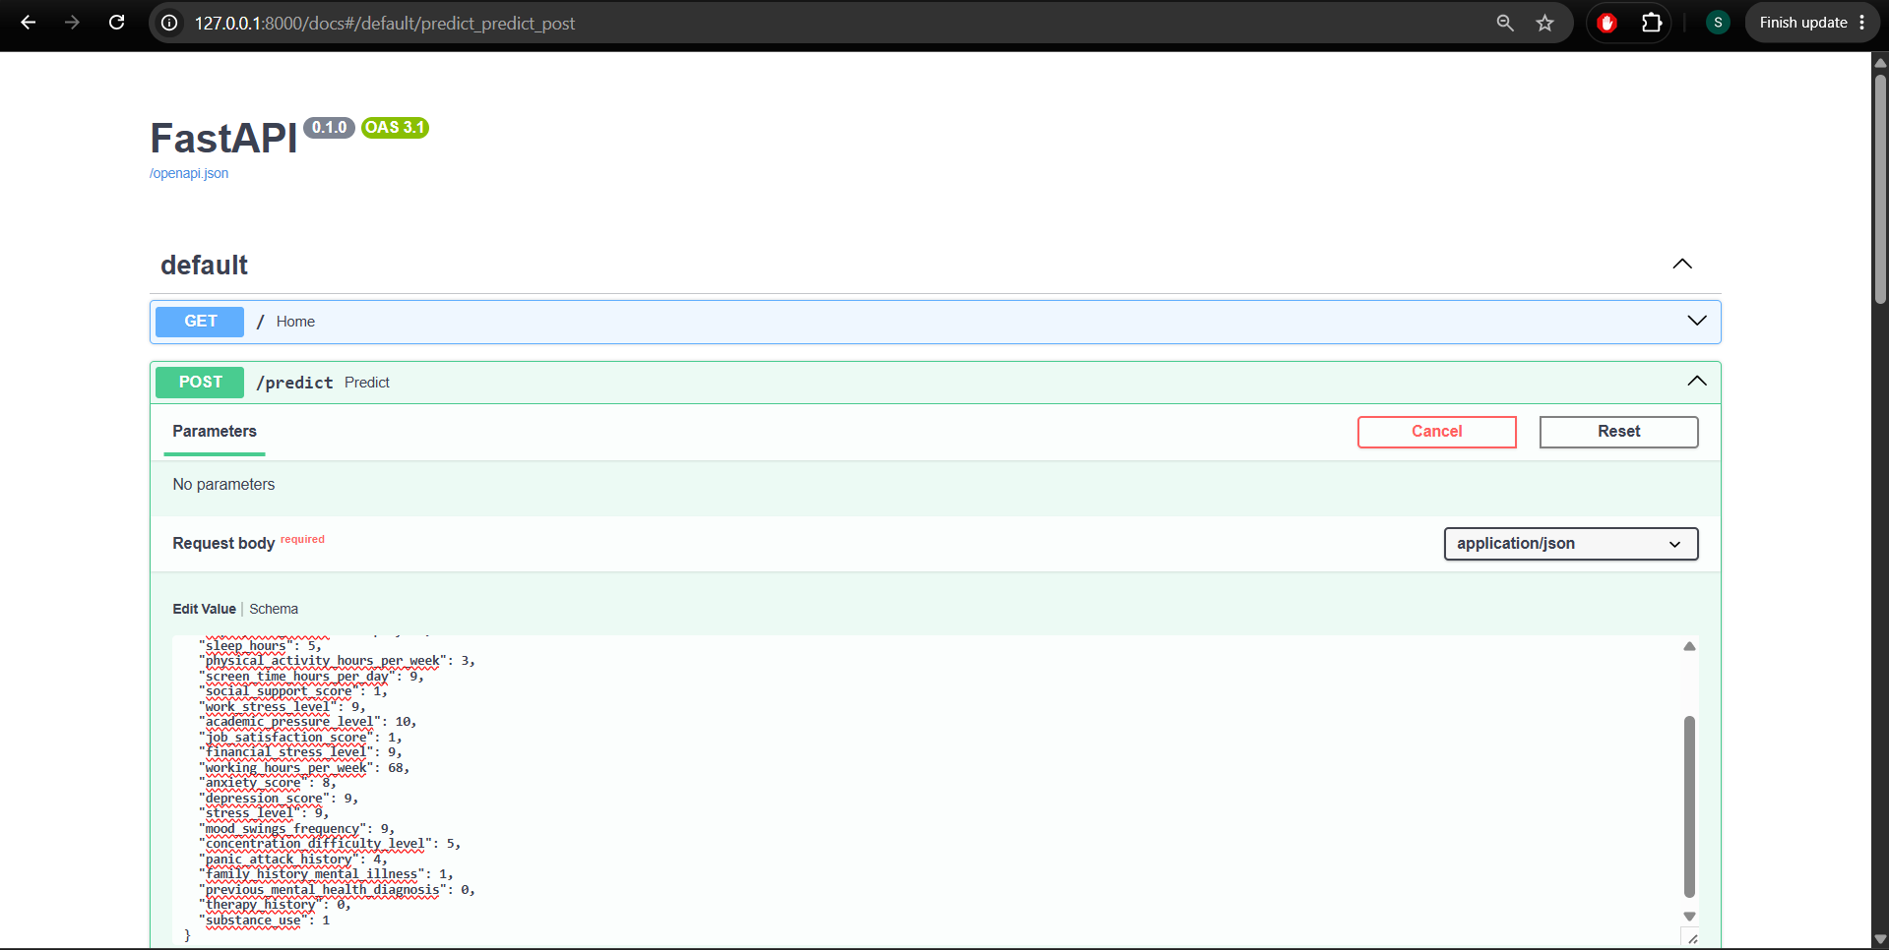
4.4 Get-Post Fast API
4.7 Frontend Implementation
The frontend of the application was developed using Streamlit due to its simplicity, rapid development capabilities, and seamless integration with Python-based machine learning applications.
The user interface was designed with the objective of providing a clean and intuitive assessment experience. The application consists of three major pages:
- Landing Page
- Assessment Page
- Results Page
Each page serves a specific purpose within the overall workflow.
4.7.1 Landing Page
The landing page introduces the application and briefly explains its objective. It also informs users that the prediction is intended for educational purposes and should not replace professional medical advice.
The landing page provides a "Start Assessment" button that redirects users to the questionnaire.
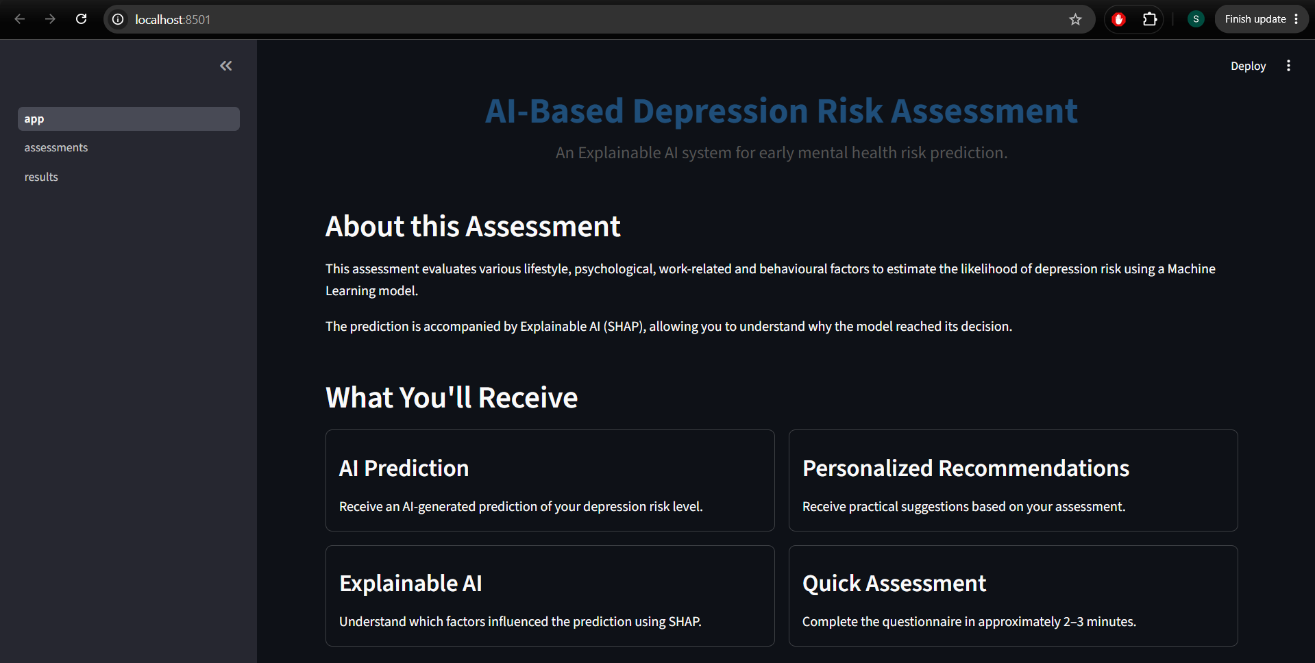
4.5 Landing Page
4.7.2 Assessment Page
The assessment page contains a structured questionnaire divided into six logical sections.
- Basic Information
- Lifestyle
- Work & Academic Information
- Mental Health Assessment
- Clinical History
- Additional Information
The questionnaire utilizes multiple Streamlit widgets including:
- Number Input
- Sliders
- Radio Buttons
- Select Boxes
The responses are stored temporarily using Streamlit Session State before being submitted to the FastAPI backend.
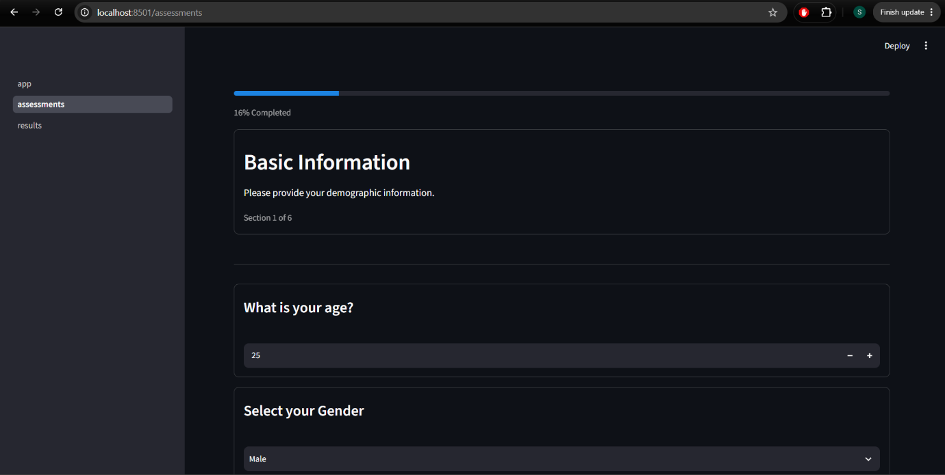
4.6 Assessment Page
4.7.3 Results Page
The results page displays the prediction generated by the machine learning model.
The following information is presented:
- Depression Risk Category
- Prediction Confidence
- Assessment Summary
- SHAP-based Feature Importance
- Personalized Recommendations
Users can either return to the homepage or retake the assessment after reviewing the prediction.
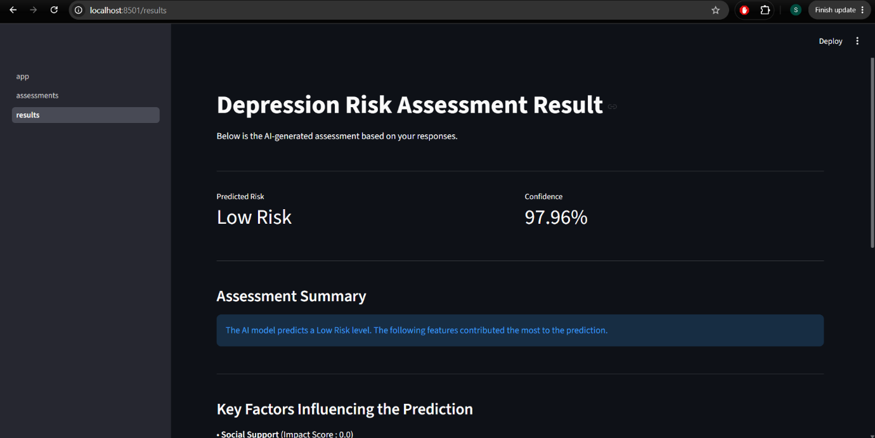
4.7 Result page

4.8 API Integration
Communication between the frontend and backend is established through HTTP requests.
When the user submits the assessment, Streamlit converts all responses into JSON format and sends them to the FastAPI prediction endpoint.
The FastAPI backend processes the request and returns a structured JSON response containing:
- Predicted Risk
- Confidence Score
- Assessment Summary
- Top Contributing Features
- Personalized Recommendations
The frontend parses the response and displays the information in an organized format.
This separation between frontend and backend improves scalability and allows independent modification of either component without affecting the other.
4.9 Machine Learning Model Integration
The trained XGBoost classification model was integrated into the backend using the Joblib serialization library. Model serialization enables the trained machine learning model to be stored as a file after training and later loaded during deployment without requiring retraining.
During application startup, the serialized preprocessing pipeline and trained XGBoost classifier are loaded into memory. Loading the model only once during server initialization significantly reduces prediction time and improves application performance.
When a user submits the assessment, the backend performs the following sequence of operations:
- Receive the assessment responses.
- Validate the incoming JSON data.
- Convert the responses into a Pandas DataFrame.
- Apply the trained preprocessing pipeline.
- Generate prediction using the XGBoost classifier.
- Calculate prediction confidence.
- Generate SHAP explanations.
- Produce personalized recommendations.
- Return the final response to the frontend.
Since the preprocessing pipeline is embedded within the deployed model workflow, every prediction follows the exact same transformations used during model training, ensuring consistency and reliability.
4.9.1 Model Loading
The machine learning model is loaded once when the FastAPI server starts.
This approach offers several advantages:
- Faster prediction response.
- Reduced CPU utilization.
- Avoids repeated model loading.
- Improves scalability.
- Supports concurrent API requests.
Loading the model during initialization minimizes latency and ensures efficient execution throughout the application's lifecycle.

4.10 SHAP Implementation
Interpretability is an essential requirement in healthcare-related machine learning systems. To satisfy this requirement, SHAP (SHapley Additive exPlanations) was integrated into the prediction pipeline.
After the XGBoost model generates the predicted depression risk category, SHAP computes the contribution of every feature toward that specific prediction.
Unlike traditional feature importance techniques, SHAP explains individual predictions rather than only describing the overall behavior of the model.
The SHAP implementation follows the following workflow:
- Receive transformed feature values.
- Calculate SHAP values for all input features.
- Compute the absolute contribution of every feature.
- Rank the features according to their impact.
- Select the top three influential features.
- Display the corresponding impact scores on the results page.
This enables users to understand why the model generated a particular prediction instead of simply observing the predicted risk category.
4.10.1 SHAP Output
For each assessment, the application displays:
- Top three contributing features.
- SHAP impact score for each feature.
- Personalized recommendations generated using these features.
The explainability module improves transparency and helps users understand the relationship between their lifestyle and the predicted depression risk.

4.11 Recommendation Engine
The recommendation engine was developed to convert prediction explanations into meaningful suggestions for users.
Rather than providing identical advice to every individual, the system analyzes the top contributing features obtained from SHAP and maps them to predefined health recommendations.
Influential Feature | Recommendation
Sleep Duration | Maintain a regular sleep schedule of 7–9 hours per night.
Work Stress | Practice stress management techniques and maintain work-life balance.
Social Support | Strengthen communication with family and trusted friends.
Depression Score | Consider consulting a qualified mental health professional if symptoms persist.
Anxiety Score | Practice relaxation exercises and mindfulness techniques.

4.12 User Interface Design
The user interface was developed using Streamlit with the objective of providing a simple, responsive, and intuitive user experience.
The interface was designed using a minimalistic approach so that users can easily navigate through the assessment without unnecessary distractions.
Several design principles were considered during development:
- Clear navigation.
- Consistent layout.
- Readable typography.
- Structured questionnaire.
- Responsive design.
- Easy-to-understand results presentation.
The interface consists of three primary modules:
- Landing Page
- Assessment Page
- Results Page
Each module performs a dedicated function while maintaining a consistent design throughout the application.
4.12.1 Landing Page
The landing page introduces the application and provides users with an overview of the system.
The page includes:
- Project title.
- Brief description.
- Disclaimer.
- Features offered by the system.
- Start Assessment button.
This page serves as the entry point of the application.
4.12.2 Assessment Page
The assessment page presents the questionnaire in six logical sections.
Displaying multiple related questions within a single page minimizes excessive navigation and improves user engagement.
The questionnaire includes:
- Number inputs.
- Sliders.
- Radio buttons.
- Dropdown selections.
Progress indicators help users understand how much of the assessment has been completed.
4.12.3 Results Page
The results page presents the prediction in a structured format.
Displayed information includes:
- Depression Risk Level.
- Prediction Confidence.
- Assessment Summary.
- SHAP Feature Contributions.
- Personalized Recommendations.
Users can either retake the assessment or return to the homepage using dedicated action buttons.

4.13 System Workflow
The execution sequence is summarized below:
- User opens the application.
- Landing page is displayed.
- User begins the assessment.
- Questionnaire responses are collected.
- Streamlit stores responses temporarily.
- Responses are transmitted to the FastAPI backend.
- FastAPI validates the received data.
- The preprocessing pipeline transforms the input.
- XGBoost predicts the depression risk category.
- SHAP computes feature importance.
- Recommendations are generated.
- The backend returns prediction results.
- Streamlit displays the final output.
This workflow ensures efficient communication among all system components while maintaining modularity.
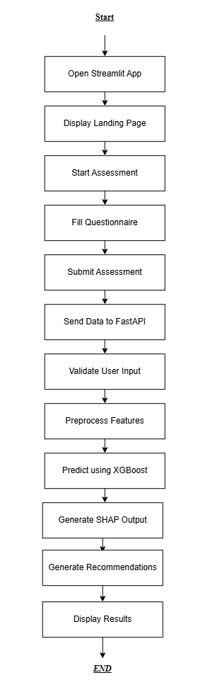
4.8 Flowchart Diagram
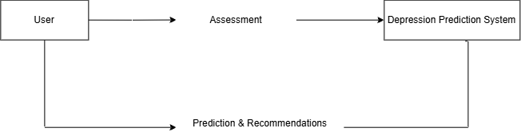
4.9 DFD Level 0 Diagram
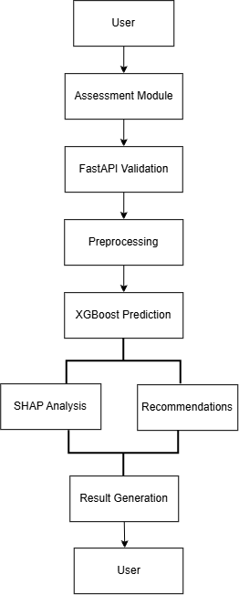
4.10 DFD Level 1 Diagram
4.14 Advantages of the Proposed System
The developed system offers several advantages compared to traditional prediction systems.
- Provides real-time depression risk prediction.
- Utilizes a highly accurate XGBoost classification model.
- Explains every prediction using SHAP.
- Generates personalized recommendations.
- User-friendly web interface.
- Fast backend using FastAPI.
- Modular architecture.
- Easy deployment and maintenance.
- Scalable for future enhancements.
These characteristics make the system suitable for educational demonstrations and research applications in mental health analytics.

4.15 Limitations of the Proposed System
Despite its effectiveness, the proposed system has several limitations.
- Predictions depend entirely on user-provided responses.
- The model cannot replace professional psychological diagnosis.
- Recommendations are based on predefined rules rather than expert consultation.
- The system currently supports only structured questionnaire data.
- Clinical reports, wearable sensor data, and medical imaging are not incorporated.
These limitations provide opportunities for future research and improvement.

4.16 Chapter Summary
This chapter described the design and implementation of the Explainable AI-Based Depression Risk Prediction System. It discussed the overall software architecture, backend implementation using FastAPI, frontend development using Streamlit, integration of the trained XGBoost model, SHAP-based explainability, and the recommendation engine. The chapter also explained the interaction among different software components and highlighted the strengths and limitations of the proposed system.

CHAPTER 5
RESULTS AND DISCUSSION
5.1 Introduction
This chapter presents the experimental results obtained from the Explainable AI-Based Depression Risk Prediction System. It evaluates the performance of different machine learning algorithms, compares their predictive capabilities, analyzes the effectiveness of the selected XGBoost classifier, and discusses the interpretability provided by SHAP. Furthermore, this chapter demonstrates the functionality of the deployed web application developed using Streamlit and FastAPI.
The objective of this chapter is to verify that the proposed system accurately predicts depression risk while simultaneously providing meaningful explanations and personalized recommendations.

5.2 Experimental Environment
The proposed system was developed and evaluated using the following software environment.
Component | Specification
Programming Language | Python 3.12
IDE | Visual Studio Code
Notebook Environment | Jupyter Notebook
Machine Learning Library | Scikit-learn
Classification Algorithm | XGBoost
Explainable AI | SHAP
Backend Framework | FastAPI
Frontend Framework | Streamlit
Version Control | GitHub

5.3 Dataset Summary
The dataset used for model development consists of demographic, lifestyle, occupational, psychological, and medical history information collected from individuals for depression risk assessment.
Property | Value
Total Records | 25,000
Input Features | 24
Target Variable | Mental Health Risk
Number of Classes | 3
Missing Values | None
Duplicate Records | None
The dataset contains sufficient diversity to train and evaluate a multi-class classification model while representing multiple factors associated with depression risk.

5.4 Model Comparison
Four supervised learning algorithms were trained and evaluated using the same training and testing datasets.
The objective was to identify the model providing the highest predictive accuracy while maintaining good generalization capability.
Algorithm | Accuracy
Logistic Regression | 75.04%
Random Forest | 96.26%
Decision Tree | 99.10%
XGBoost | 99.88%
The experimental results indicate that XGBoost achieved the highest prediction accuracy among all evaluated algorithms.
Its superior performance can be attributed to gradient boosting, regularization techniques, and its ability to capture complex non-linear relationships among features.

5.5 Hyperparameter Tuning Results
To further improve prediction performance, Randomized Search Cross Validation was performed for the XGBoost classifier.
The optimized hyperparameters are presented below.
Hyperparameter | Best Value
n_estimators | 200
max_depth | 5
learning_rate | 0.1
subsample | 1.0
colsample_bytree | 0.8
The optimized model demonstrated improved generalization while maintaining high predictive accuracy on unseen data.

5.6 Cross Validation Results
To evaluate model stability, Five-Fold Cross Validation was performed.
Fold | Accuracy
Fold 1 | 99.90%
Fold 2 | 99.88%
Fold 3 | 99.84%
Fold 4 | 99.90%
Fold 5 | 99.78%
Average Cross Validation Accuracy:
99.86%
Standard Deviation:
0.000456
The low standard deviation demonstrates that the model performs consistently across different subsets of the dataset, indicating excellent generalization capability.

5.7 Classification Report
The optimized XGBoost classifier achieved high precision, recall, and F1-score across all three depression risk categories.
The classification report indicates balanced performance across all classes, demonstrating that the classifier effectively distinguishes between Low Risk, Moderate Risk, and High Risk individuals.
The high recall values reduce the probability of missing high-risk individuals, which is particularly important in mental health applications.
Accuracy: 0.9988
precision recall f1-score support

0 1.00 1.00 1.00 1871
1 1.00 1.00 1.00 2365
2 1.00 0.99 1.00 764

accuracy 1.00 5000
macro avg 1.00 1.00 1.00 5000
weighted avg 1.00 1.00 1.00 5000

5.8 Explainable AI Results
One of the key objectives of this project was not only to predict depression risk but also to explain the prediction.
SHAP successfully identified the most influential features responsible for each prediction.
For example, individuals classified as High Risk frequently exhibited higher contributions from features such as:
- Depression Score
- Sleep Duration
- Panic Attack History
Conversely, individuals predicted as Low Risk often showed lower contributions from these variables while displaying healthier values for social support and stress-related attributes.
The SHAP explanation module enables users to understand the reasoning behind the prediction rather than simply observing the final result.
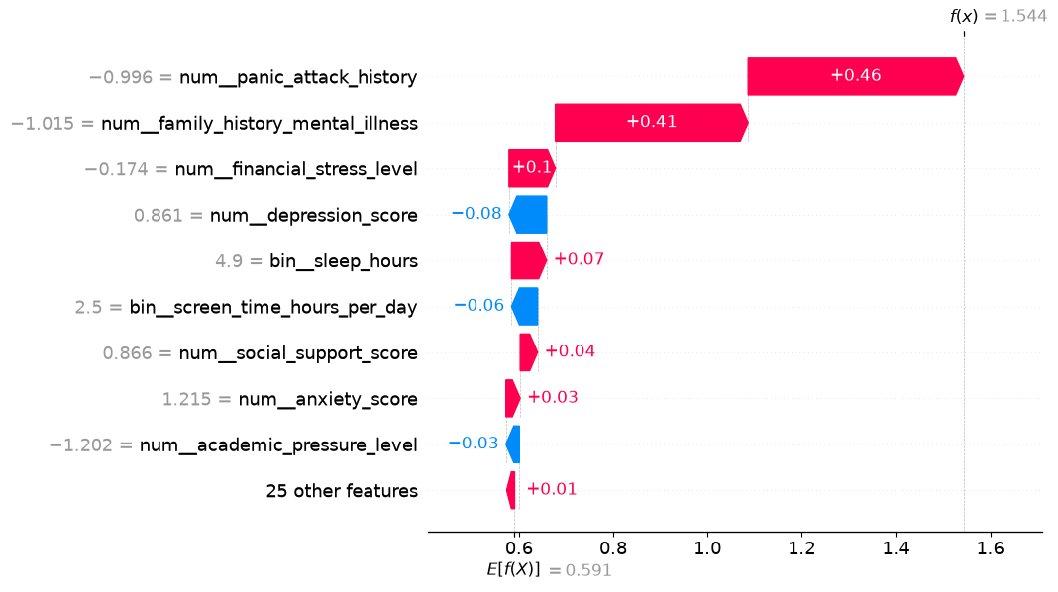
4.11 SHAP Explanation

5.9 Streamlit Application Results
The developed Streamlit application successfully integrates the frontend interface with the FastAPI backend and machine learning model.
The application consists of three major interfaces:
- Landing Page
- Assessment Page
- Results Page
The Landing Page introduces the application and allows users to begin the assessment.
The Assessment Page collects demographic, lifestyle, occupational, and psychological information through an interactive questionnaire.
After submitting the assessment, the Results Page displays:
- Depression Risk Level
- Prediction Confidence
- Assessment Summary
- SHAP Explanation
- Personalized Recommendations
The integration between Streamlit and FastAPI was successfully implemented, allowing real-time prediction without requiring model retraining.

5.11 Discussion
The experimental evaluation demonstrates that the proposed Explainable AI-Based Depression Risk Prediction System achieves excellent predictive performance while maintaining interpretability.
Among the evaluated algorithms, XGBoost consistently outperformed Logistic Regression, Decision Tree, and Random Forest. Hyperparameter tuning further improved model performance, resulting in high classification accuracy and stable cross-validation scores.
The integration of SHAP significantly enhanced the transparency of the system by explaining individual predictions through feature contribution analysis. Additionally, the recommendation engine converted these explanations into practical mental health suggestions, increasing the usefulness of the application.
The deployment of the trained model using FastAPI and Streamlit successfully transformed the machine learning model into a fully functional web application capable of generating real-time predictions.
Overall, the proposed system satisfies the objectives defined at the beginning of the project by combining high prediction accuracy, explainability, and an intuitive user interface within a single application.

5.12 Chapter Summary
This chapter presented the experimental evaluation of the proposed depression prediction system. Multiple machine learning algorithms were compared, with XGBoost achieving the highest predictive performance. Hyperparameter tuning and cross-validation confirmed the robustness of the selected model. SHAP successfully explained individual predictions, while the Streamlit and FastAPI integration enabled real-time deployment of the model. The results demonstrate that the proposed system provides accurate, interpretable, and user-friendly depression risk prediction.

CHAPTER 6
CONCLUSION AND FUTURE SCOPE
6.1 Conclusion
Mental health disorders, particularly depression, have become one of the most significant public health concerns worldwide. Early identification of individuals at risk can facilitate timely intervention and improve overall well-being. Motivated by this need, this project proposed an Explainable AI-Based Depression Risk Prediction System capable of predicting an individual's depression risk using demographic, lifestyle, occupational, psychological, and clinical information.
A comprehensive machine learning pipeline was developed, beginning with data preprocessing, feature transformation, and model training. Multiple supervised learning algorithms were evaluated, including Logistic Regression, Decision Tree, Random Forest, and XGBoost. Among these, the XGBoost classifier demonstrated the highest predictive performance and was therefore selected as the final model.
To overcome the interpretability limitations commonly associated with machine learning models, SHAP was integrated into the prediction pipeline. Instead of presenting only the predicted risk level, the system explains the factors influencing each prediction and provides personalized recommendations based on those factors.
The trained model was successfully deployed using a FastAPI backend and integrated with a Streamlit-based web application, enabling real-time depression risk assessment through an intuitive user interface. The final system demonstrates that machine learning, explainable AI, and modern web technologies can be effectively combined to create an accessible decision-support application.
Overall, the proposed system achieved the objectives defined at the beginning of the project by delivering accurate predictions, meaningful explanations, and a user-friendly deployment platform.

6.2 Deployment Architecture
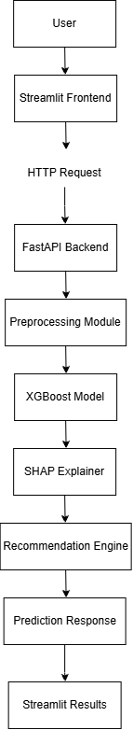
4.12 Deployment Architecture

6.3 Project Contributions
The major contributions of this project are summarized below:
- Developed a complete end-to-end depression risk prediction system using machine learning.
- Evaluated multiple classification algorithms and selected XGBoost based on predictive performance.
- Integrated Explainable AI using SHAP to provide transparent and interpretable predictions.
- Designed a personalized recommendation module based on influential prediction factors.
- Developed a responsive Streamlit web application for user interaction.
- Implemented a FastAPI backend for real-time machine learning inference.
- Established a modular software architecture that supports future scalability and maintenance
6.3 Limitations
Although the proposed system demonstrates high predictive performance, several limitations should be acknowledged.
- The system relies entirely on self-reported questionnaire responses, which may be affected by user bias.
- The dataset used for training does not include clinical records or physiological measurements.
- Recommendations are based on predefined rules and are intended only for educational purposes.
- The application does not replace professional psychological assessment or medical diagnosis.
- The current implementation supports only structured tabular data and does not incorporate text, speech, or wearable sensor information.
These limitations indicate opportunities for further research and improvement.

6.4 Future Scope
Several enhancements can be incorporated into the proposed system in future work.
- Integrate clinical records and wearable health sensor data to improve prediction accuracy.
- Incorporate Natural Language Processing techniques to analyze journal entries or textual responses.
- Develop multilingual support to increase accessibility for diverse user populations.
- Deploy the application on cloud platforms such as AWS, Azure, or Google Cloud for large-scale usage.
- Implement user authentication and secure database storage for maintaining assessment history.
- Expand the recommendation engine using Large Language Models (LLMs) to generate more personalized and context-aware mental health guidance.
- Develop a mobile application version for Android and iOS platforms.
- Conduct clinical validation studies in collaboration with mental health professionals to assess real-world applicability.
6.5 References
1) Authors: Scott M. Lundberg and Su-In Lee
Year: 2017
Title: A Unified Approach to Interpreting Model Predictions
Conference: Advances in Neural Information Processing Systems (NeurIPS 2017)
Link: https://papers.nips.cc/paper/7062-a-unified-approach-to-interpreting-model-predictions
2) Authors: Scott M. Lundberg, Gabriel G. Erion, and Su-In Lee
Year: 2018
Title: Consistent Individualized Feature Attribution for Tree Ensembles
Link: https://arxiv.org/abs/1802.03888
3) Authors: Scott M. Lundberg et al.
Year: 2020
Title: From Local Explanations to Global Understanding with Explainable AI for Trees
Journal: Nature Machine Intelligence
Link: https://www.nature.com/articles/s42256-019-0138-9
4) Authors: Tianqi Chen and Carlos Guestrin
Year: 2016
Title: XGBoost: A Scalable Tree Boosting System
Conference: ACM SIGKDD International Conference on Knowledge Discovery and Data Mining (KDD)
Link: https://dl.acm.org/doi/10.1145/2939672.2939785
5) Author: Leo Breiman
Year: 2001
Title: Random Forests
Journal: Machine Learning
Link: https://link.springer.com/article/10.1023/A:1010933404324
6) Author: J. Ross Quinlan
Year: 1986
Title: Induction of Decision Trees
Journal: Machine Learning
Link: https://link.springer.com/article/10.1007/BF00116251
7) Authors: David W. Hosmer, Stanley Lemeshow, and Rodney X. Sturdivant
Year: 2013
Title: Applied Logistic Regression (3rd Edition)
Publisher: Wiley
Link: https://onlinelibrary.wiley.com/doi/book/10.1002/9781118548387
8) Authors: Wojciech Samek, Thomas Wiegand, and Klaus-Robert Müller
Year: 2017
Title: Explainable Artificial Intelligence: Understanding, Visualizing and Interpreting Deep Learning Models
Source: arXiv
Link: https://arxiv.org/abs/1708.08296
9) Authors: Adrian B. Shatte, Delyse M. Hutchinson, and Samantha J. Teague
Year: 2019
Title: Machine Learning in Mental Health: A Scoping Review of Methods and Applications
Journal: Journal of Biomedical Informatics
Link: Link: https://www.sciencedirect.com/science/article/pii/S1532046418300866
10) Authors: Mohammad Nasir Uddin, M. M. Islam, and colleagues
Year: 2019
Title: Machine Learning-Based Depression Detection: A Review
Journal: Applied Sciences (MDPI)
Link: https://www.mdpi.com/2076-3417/9/20/4385

